1101 Bronson Way N.
Renton, WA 98057
(425) 988-3954
www.birthdaydreams.org
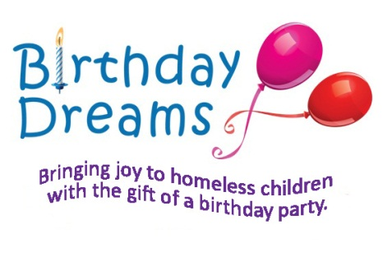

Happy Birthday!
That is what we are all about, bringing happy birthdays to homeless children in the Puget Sound area. Birthday Dreams is a non-profit organization dedicated to bringing joy to homeless children with the gift of a birthday party. Since it was founded in 2008, Birthday Dreams has helped over 1500 children celebrate their birthdays!
Shelters We Support

Auburn Youth Resources
Compass Veteran Center
Compass Housing Alliance
GD Association
First Place School (Seattle)
Hopelink
- Bellevue
- Redmond
Interfaith Family Shelter
Kith/HAC
Kent Youth & Family Services
Lifewire
Mama’s Hands (North Bend)
Mary’s Place (Seattle)
Mercy Housing
- Kent
- Tacoma
New Phoebe House
Phoenix House
Salvation Army
- Catherine Booth House
- West Seattle
Sibling House: Regional
St. Stephens Association
- Auburn
- Kent
Tacoma Rescue Mission
The Willows: Seattle
Union Gospel Mission Hope Place
Way Back In: Renton
YWCA
- Auburn
- Everett
- Family Village (Redmond)
- Federal Way
- Homeward Bound (Lynnwood)
- Kent
- Renton
- Seneca (Seattle)
- Passage Point (Maple Valley)
- Pathways (Lynnwood)
- Tacoma

Birthday Dreams is a local grassroots organization that was founded on the simple principle that every child deserves a special day. We believe that children need a sense of hope and encouragement. Our goal is to give them one day, their day, to be free of all their worries and burdens and just enjoy the excitement of their birthday party.

We have two ways to celebrate a child’s special day.

On-site Group Parties
We currently provide on-site birthday parties on a monthly basis at 6 different homeless shelters throughout the greater Puget Sound area. Kids are treated to cake, ice cream, decorations, party supplies and those celebrating their birthday receive wonderful birthday gifts. Our past events have included clowns, inflatable toys, carnival games, pony rides and other entertainment.

Birthday-in-a-Box
In some cases, group birthday parties are not viable, so we provide a Birthday-in-a-Box. Birthday Boxes are centered around a fun theme that is consistent with the child’s interests and cost on average around $100. Each Birthday-in-a-Box contains everything a parent/guardian needs to throw a birthday party for their child and up to 16 guests. A typical box has the following:
- Cake / Candles | - Themed Napkins
- Gifts | - Decorations
- Goody Bags | - Silverware
- Party Hats | - Balloons
- Themed Plates | - Juice / Cups
- Birthday Card | - Party Game

We Need Your Help!
Birthday Dreams is 100% volunteer and donation driven, which means every person, hour, item and dollar donated makes a direct difference in the life of a child. We can’t do what we do without you and we need your help and support! Please consider helping in one of the following ways today.
* Time - Volunteer * Party Sponsorship * Volunteer in our Office
* Monetary Donations * Toy Drive * Volunteer at a Party at a Shelter
* Donated Items * Sharing our Mission * Join Board of Directors/Committee

